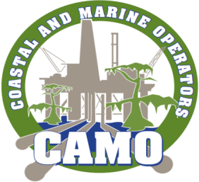 MEMBERSHIP FORM

COMPANY NAME: ___________________________________________________

MAILING ADDRESS: ___________________________________________________
___________________________________________________
___________________________________________________

CONTACT PERSON: ___________________________________________________

CONTACT PHONE (S): ___________________________________________________
___________________________________________________

CONTACT EMAIL: ___________________________________________________

COMMENTS:
_____________________________________________________________________________________________________________________________________________________________________________________________________________________________________________________________________________________________________________________________________________________________________________

Please remit this form with payment to: Questions can be directed to:
Greater Lafourche Port Commission Ed Landgraf
P.O. Box 490 Phone: (985) 873-3400
Galliano, LA 70354 Email: ed.landgraf@shell.com
FID: 72-0551223

